**Application Gateway**

Application gateway manage traffic which is come from web application.

Azure Application gateway is web traffic load balancer that enables you to manage traffic to your web application.

Traditional load balance work at osi level 4 (TCP and UDP) and route traffic based on source IP and port, to a destination Ip port

Application gateway can make decision based on HTTP request. For Ex it routes traffic based on incoming URL. So if /images is incoming url than you route traffic to specific group of server (known as pool). if /video is come than it routes traffic to that pool.

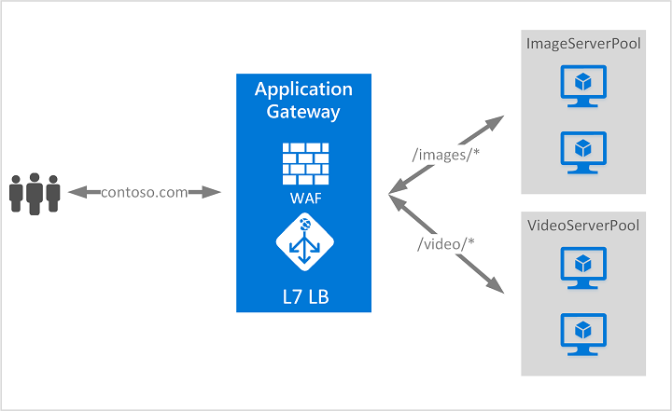

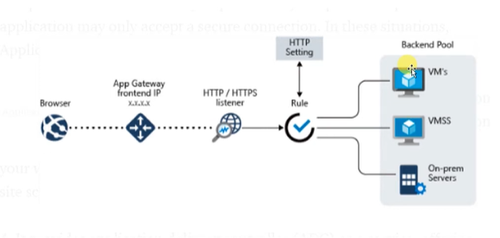

* User can communicate via frontend IP of Application gateway. instead of using direct url
* Listener check incoming request. 2 type of listener

1. Basic: if we want all of our request to be accepted and forward to backend pool
2. Multisite: if we want that request come from specific host

* Routing rules: It is used for route traffic from listener to backend pool

1. Basic: All request routed to backend pool directly
2. Path based: All request routed to backend pool based on URL

**Configuration:**

Make 2 App service

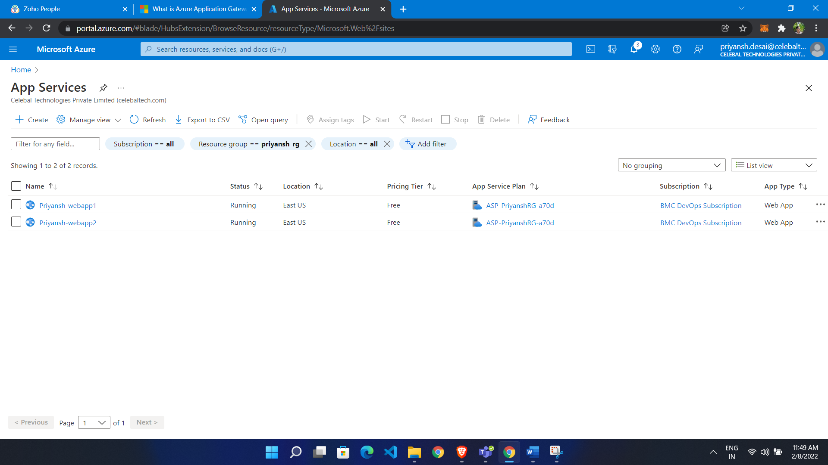

**Configure Application Gateway:**

* Go to portal
* Search application gateway
* Click create
* Give name
* Select region
* Select tier as standard V2
* If want auto scaling than choose yes
* Give min,max instance count
* Create VNET for that

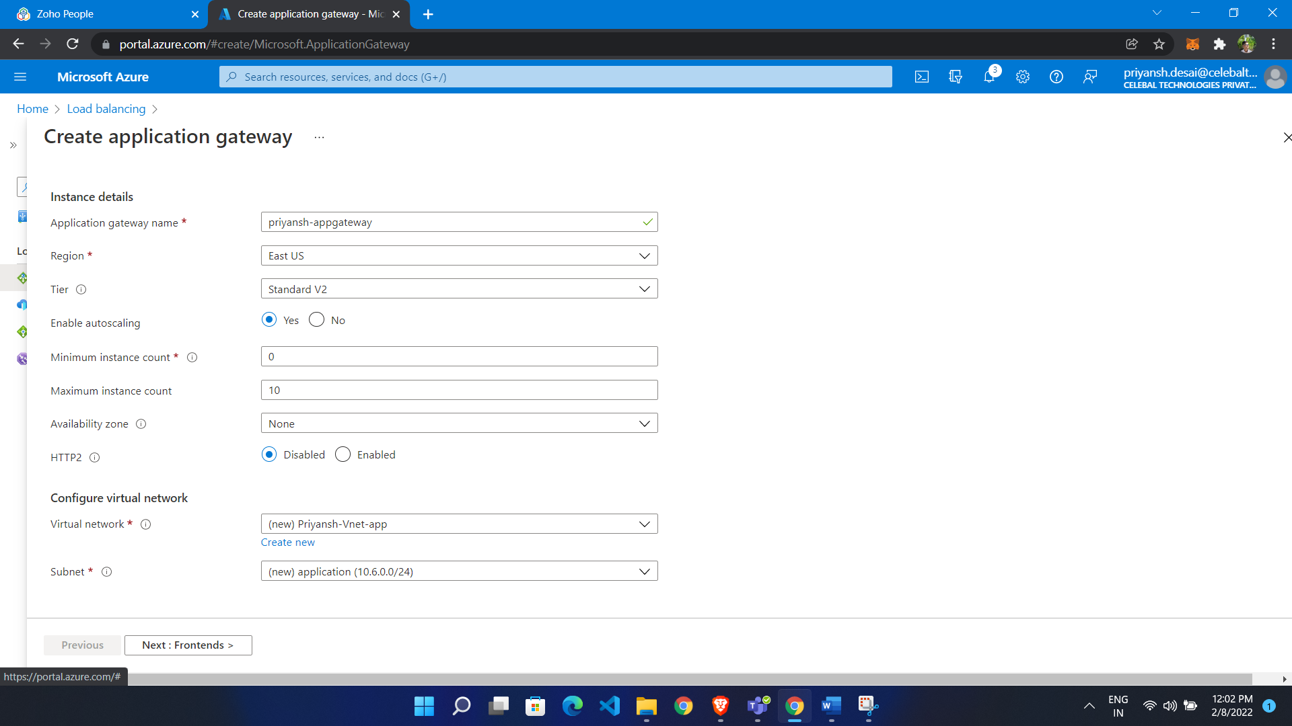

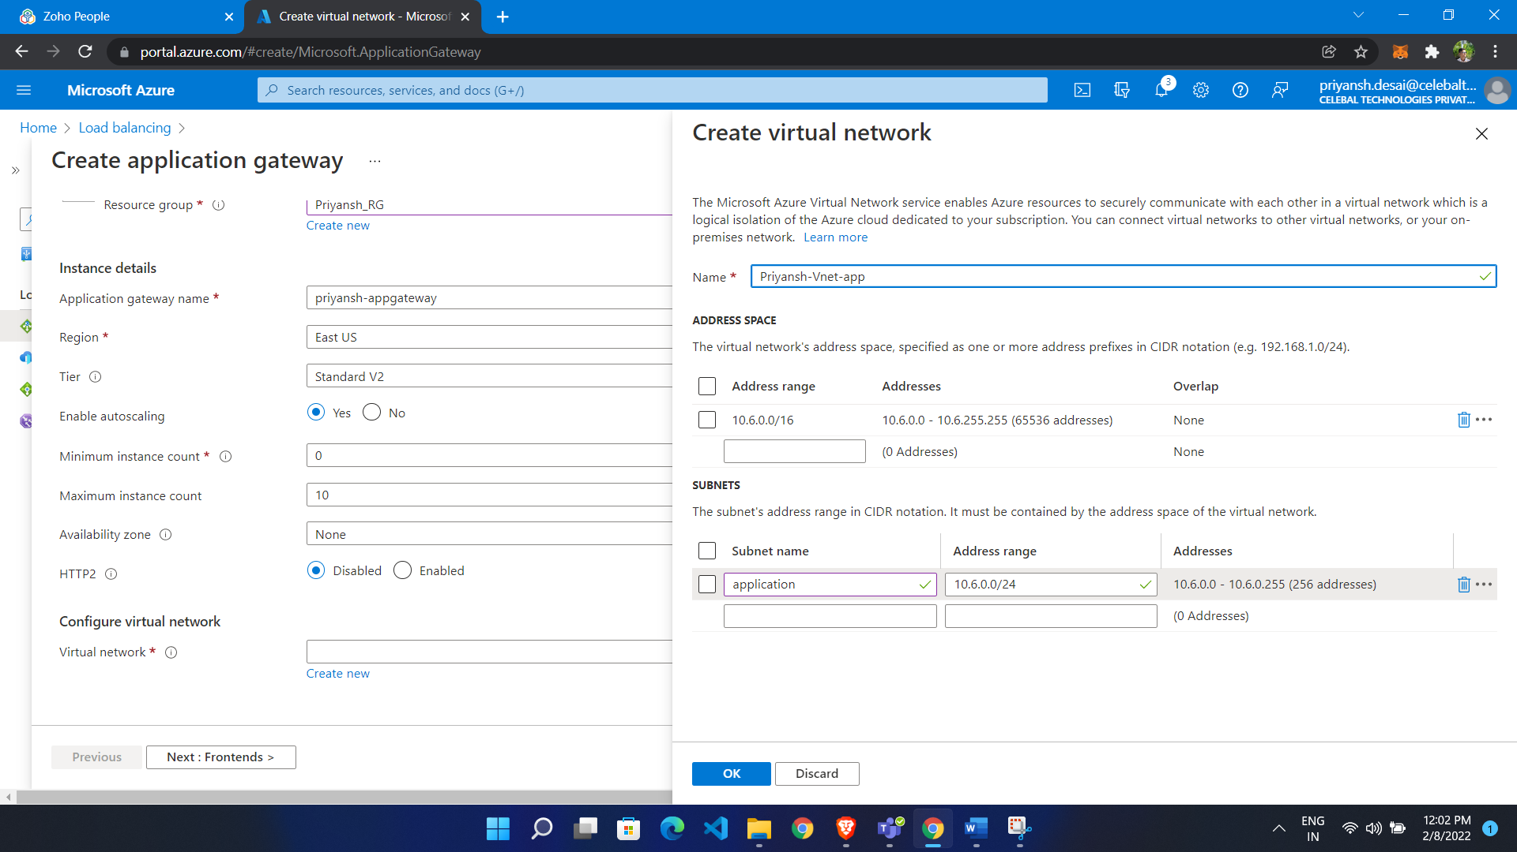

**Create Frontend IP**

* Click add new
* Give name

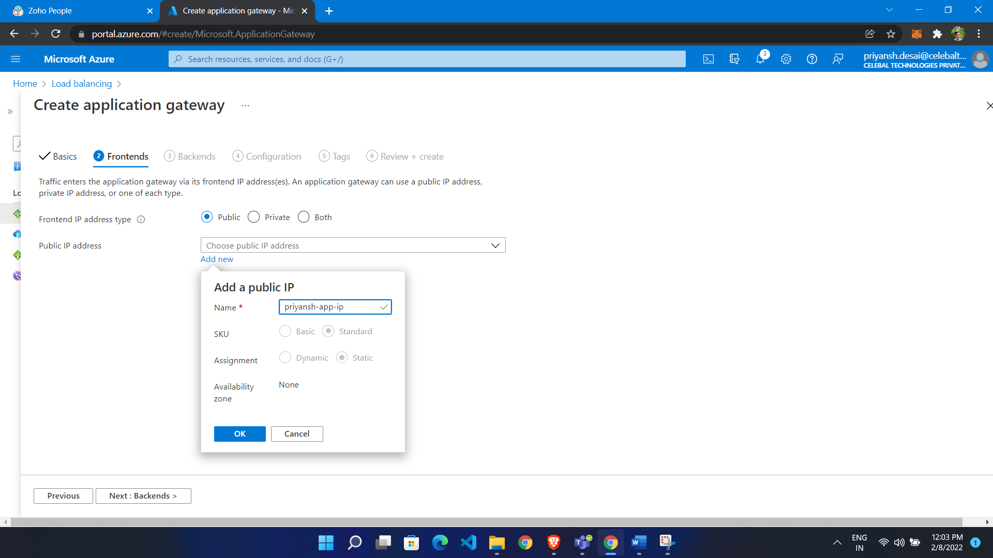

**Add Backends**

* Click Add backend pool
* Select target

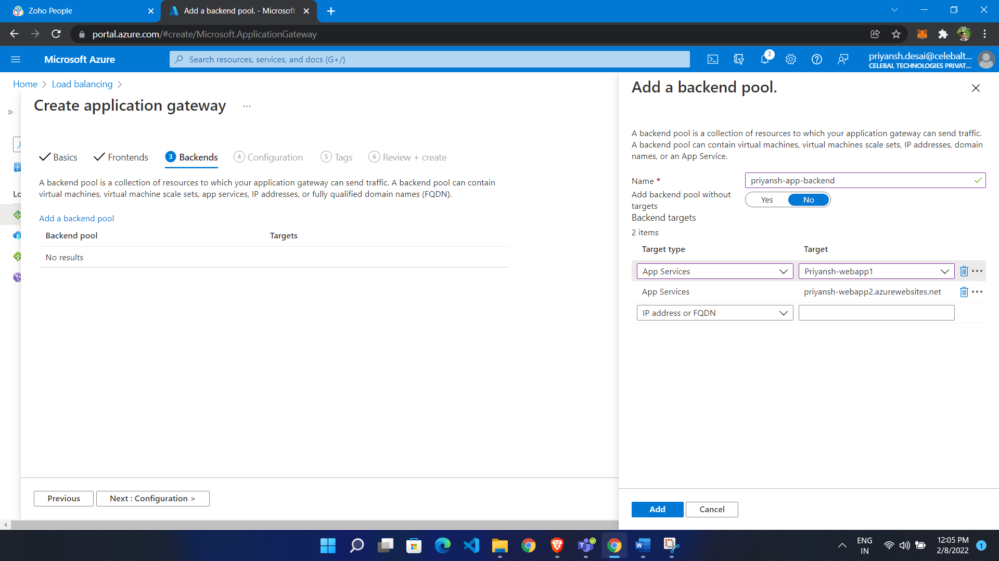

**Add Routing Rules**

* Give name
* In listener give name
* Give frontend ip as public ip

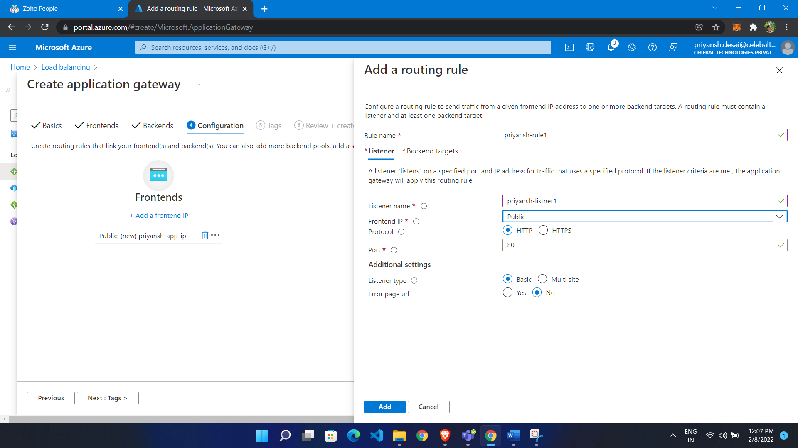

In backend target choose backend target

**Configure HTTP setting**

* Click add new
* Give name
* Remain field as its is

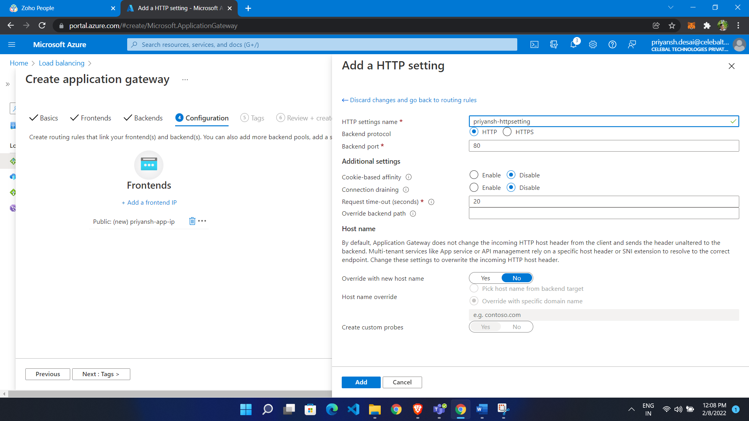

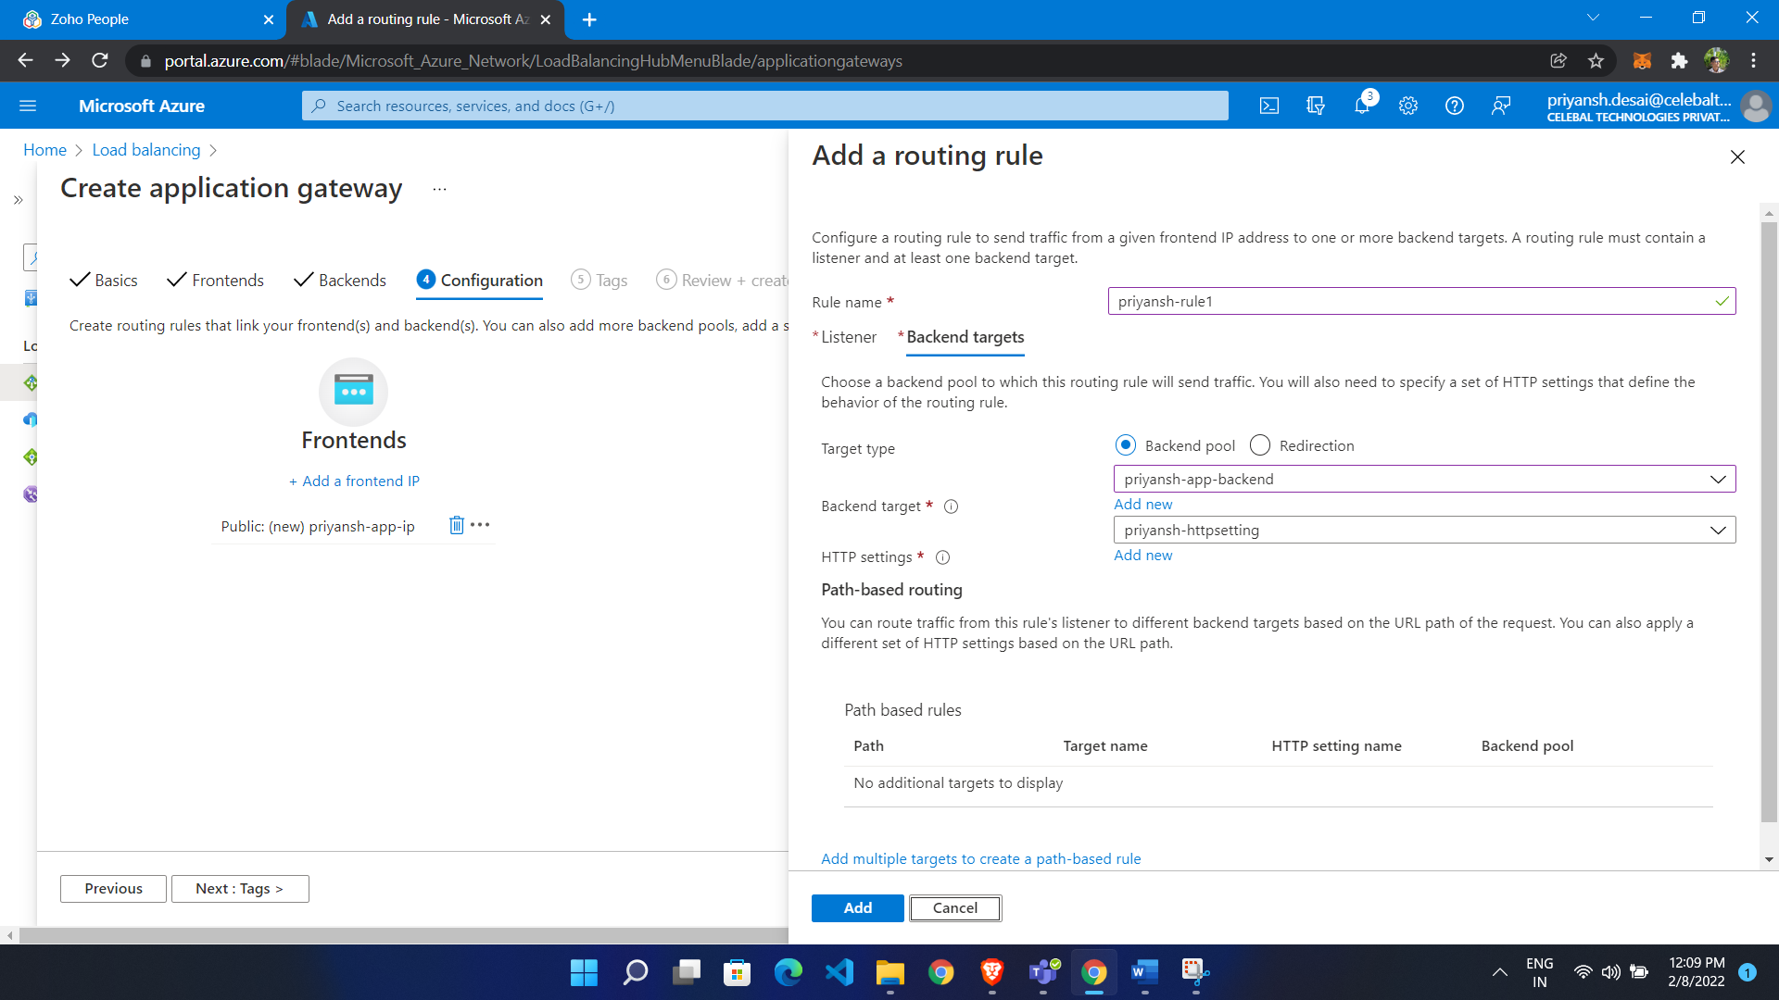

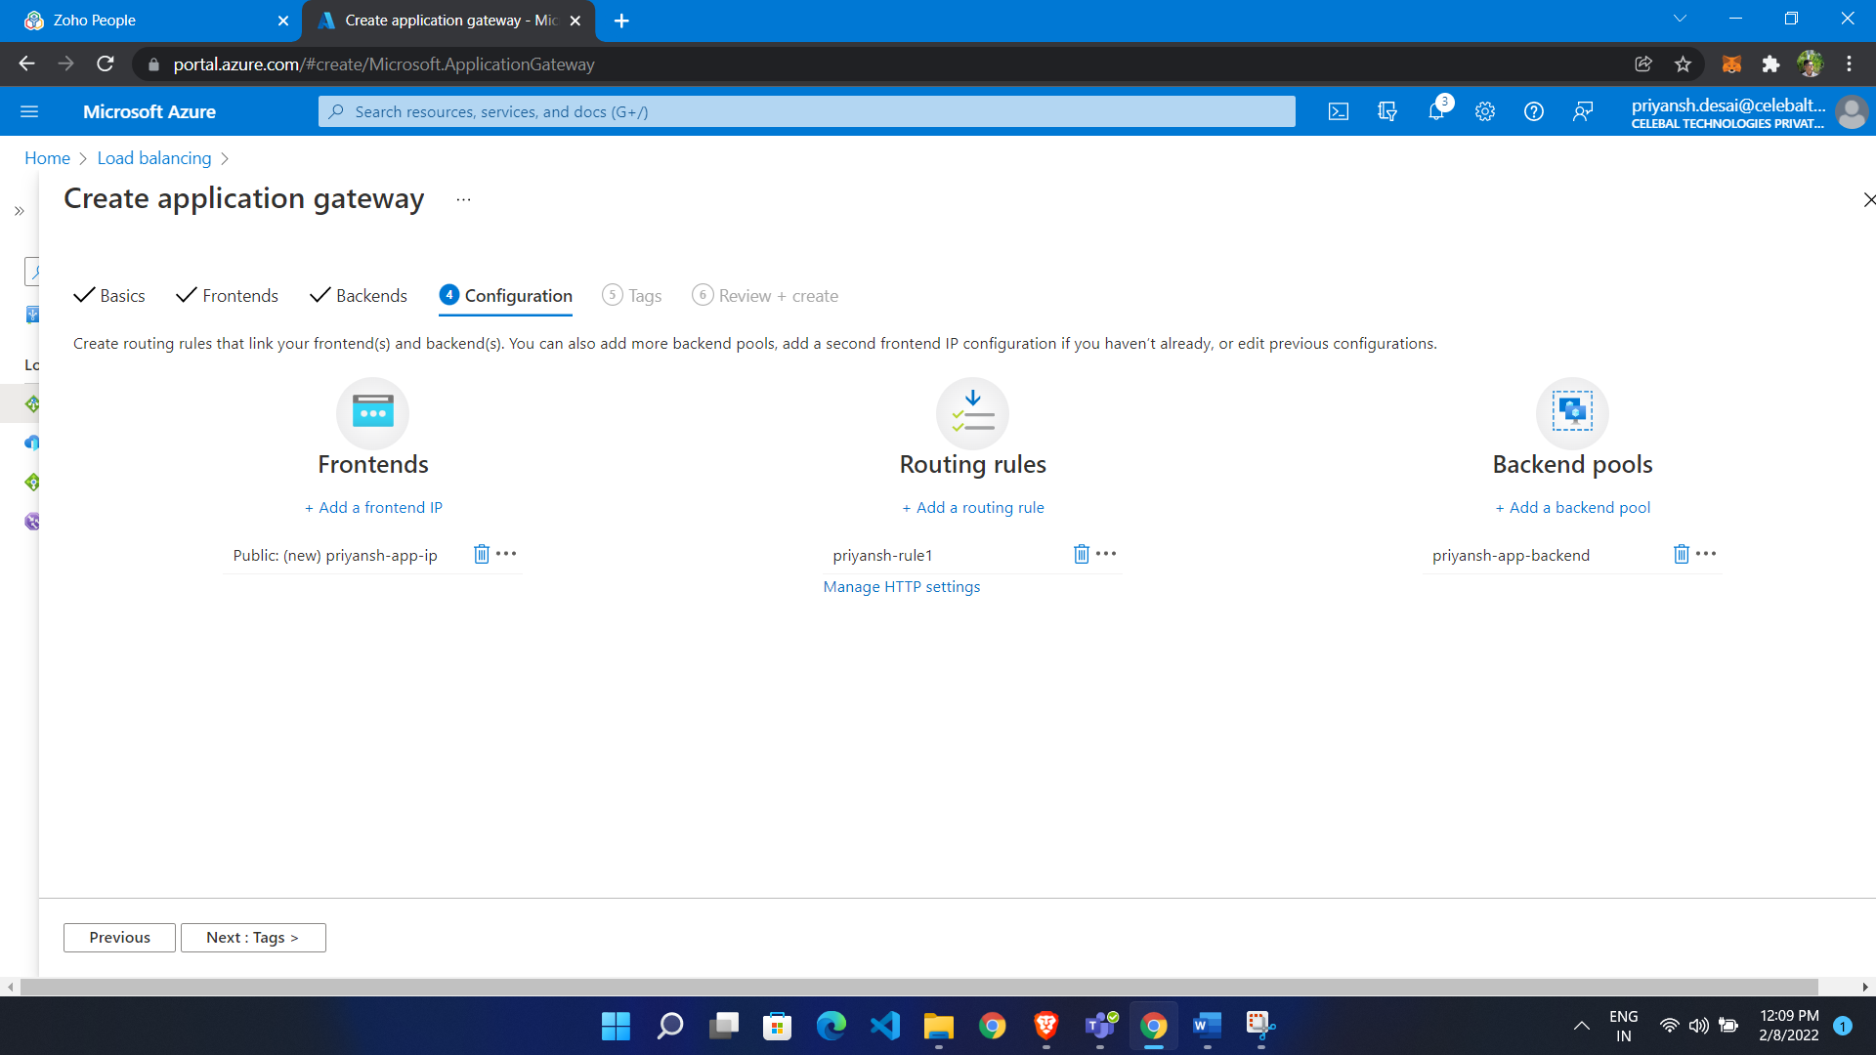

Give DNS label to frontend ip

* click frontend ip
* go to configuration
* give DNS label

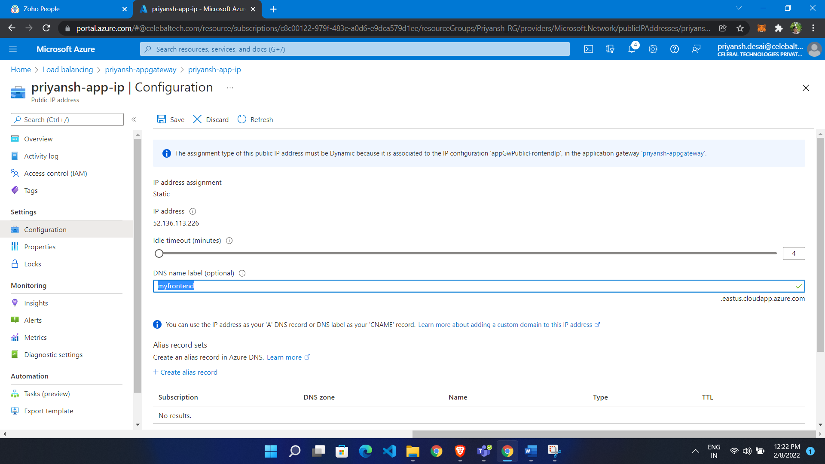

* Now go to HTTP setting
* Click override name to yes
* Select pick hostname from backend target

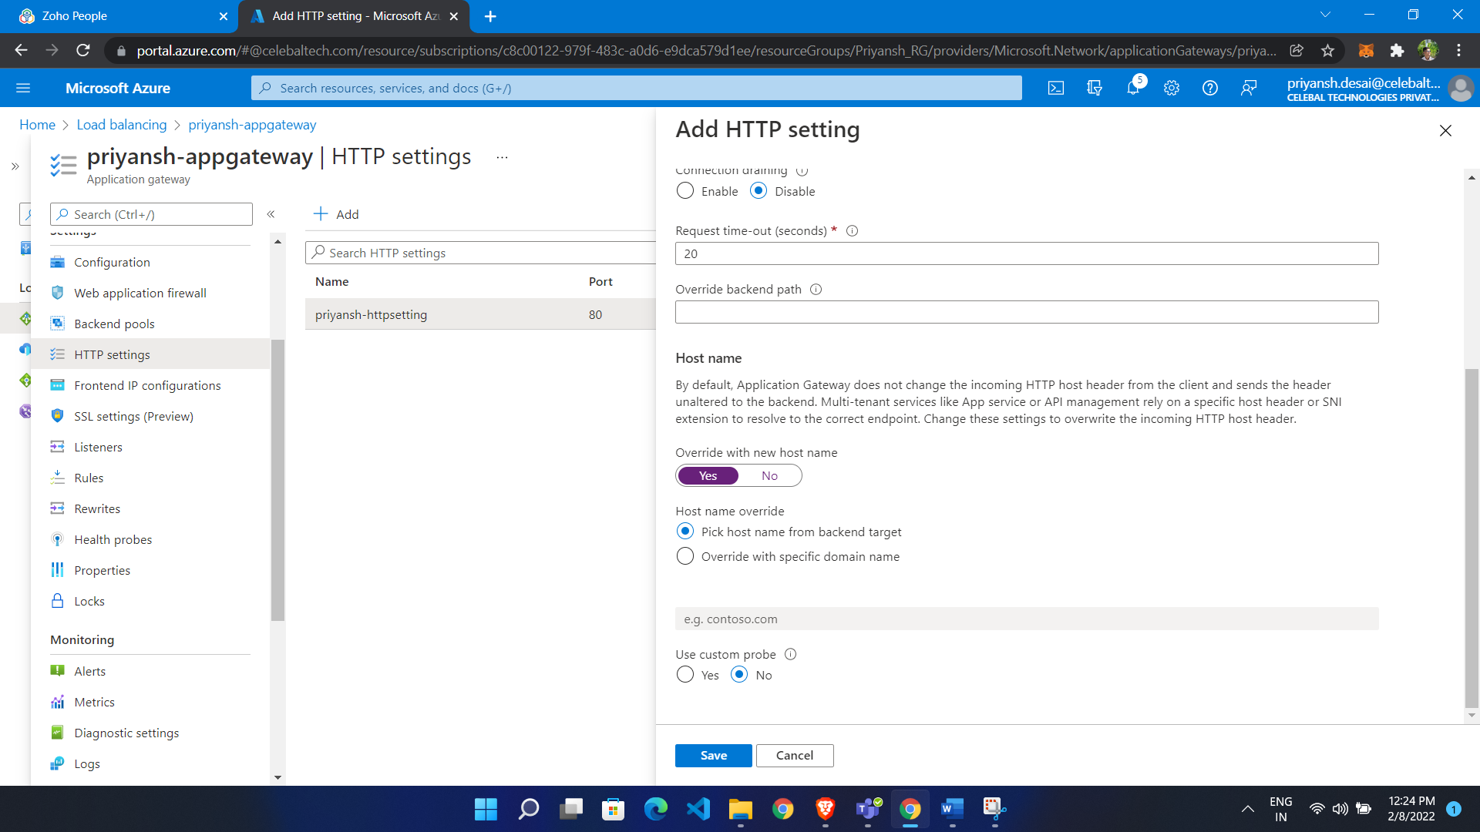

We get response from both web app

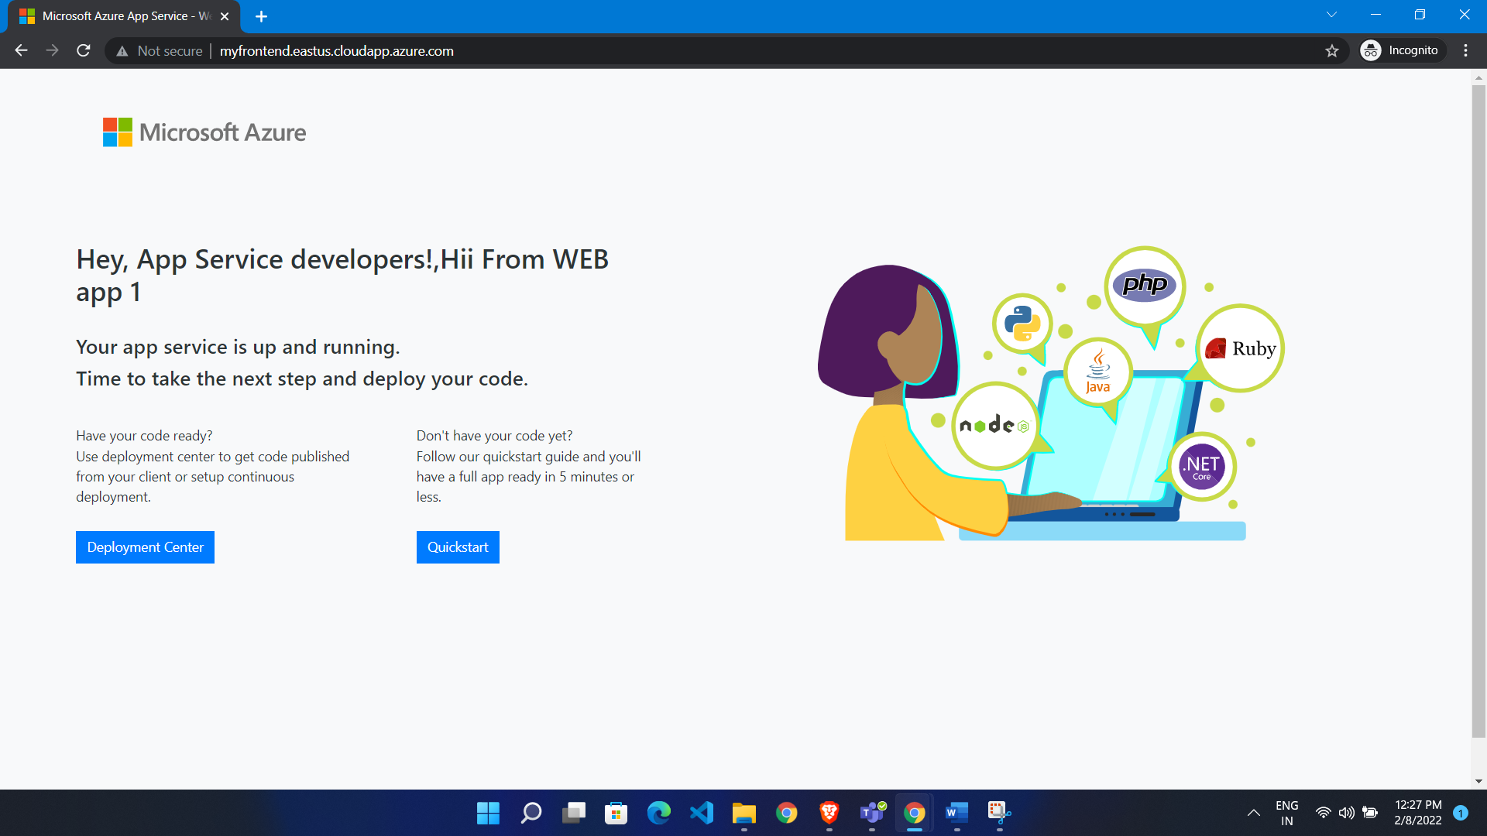

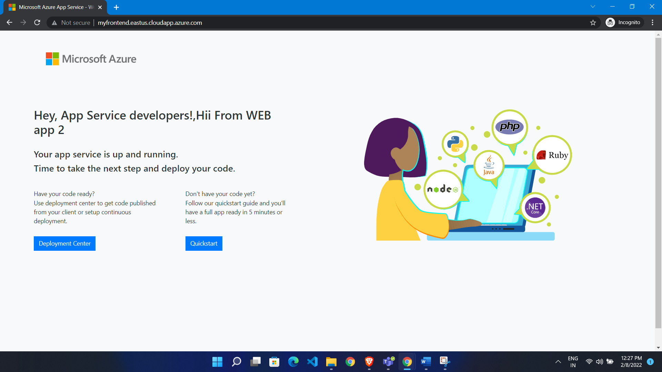

**Path based routing:**

Create 2 app service first as images 2 as video

**Configure Application gateway**

* Go to portal
* Search application gateway
* Click create
* Give name
* Select region
* Select tier as standard V2
* If want auto scaling than choose yes
* Give min,max instance count
* Create VNET for that

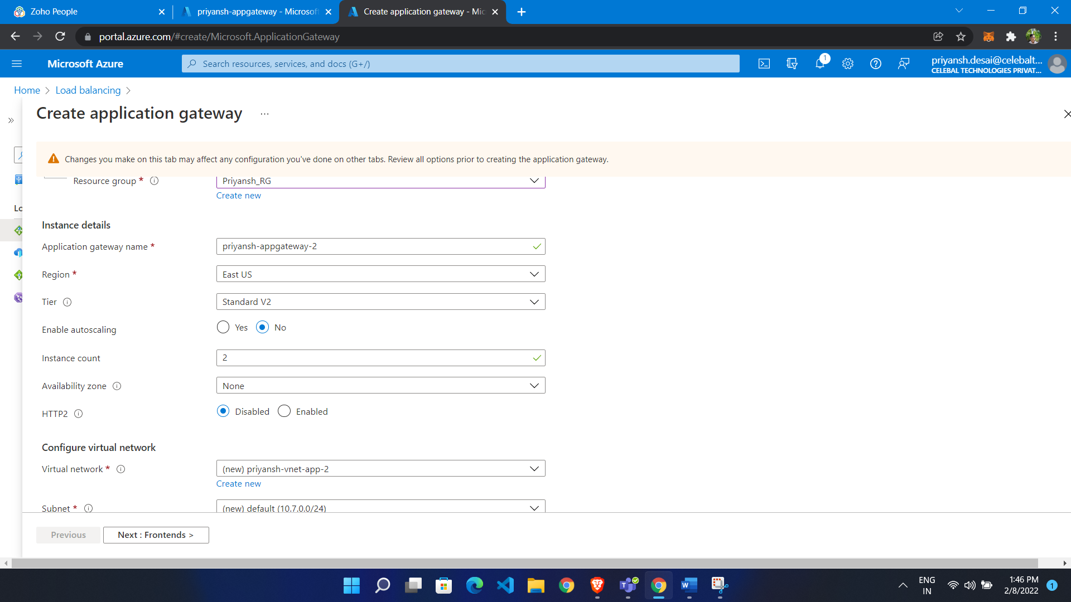

* Give frontend Ip

Add backends

* Add 2 backend
* Click add
* Choose target

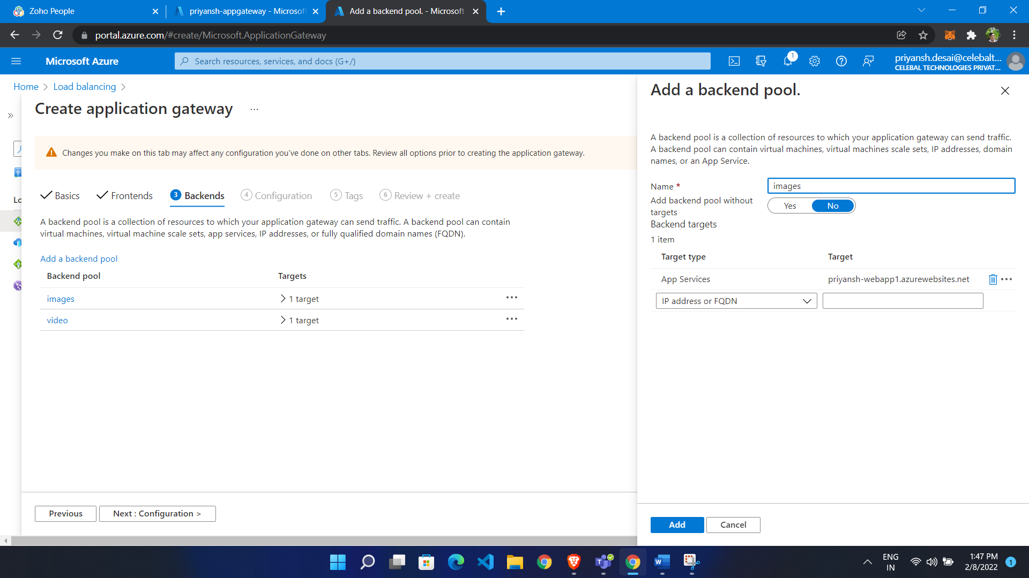

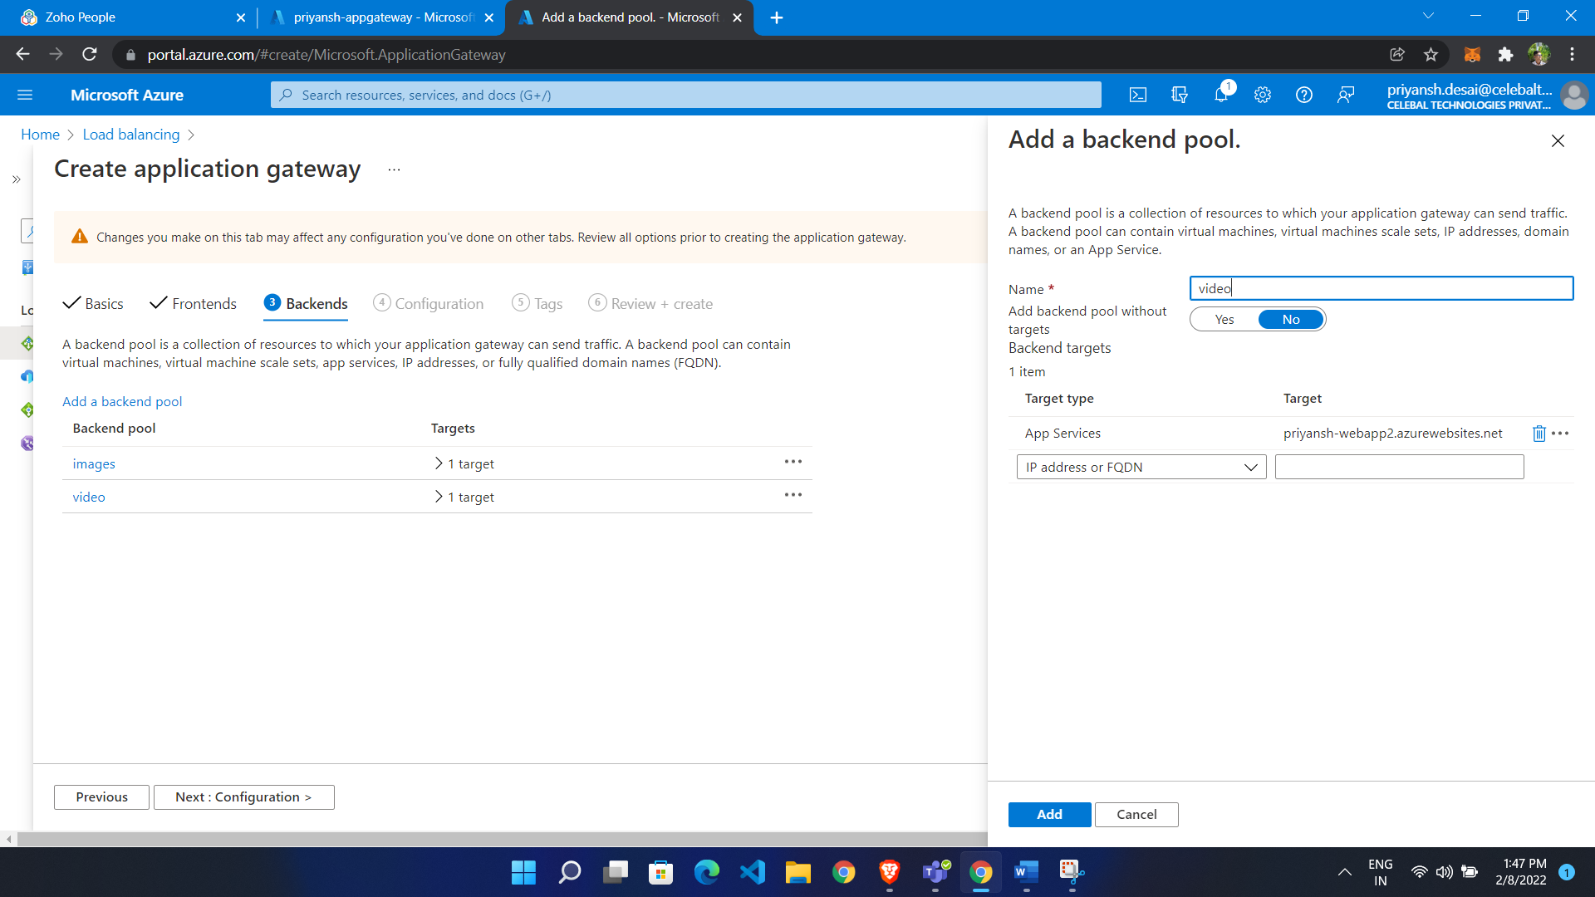

Add listener

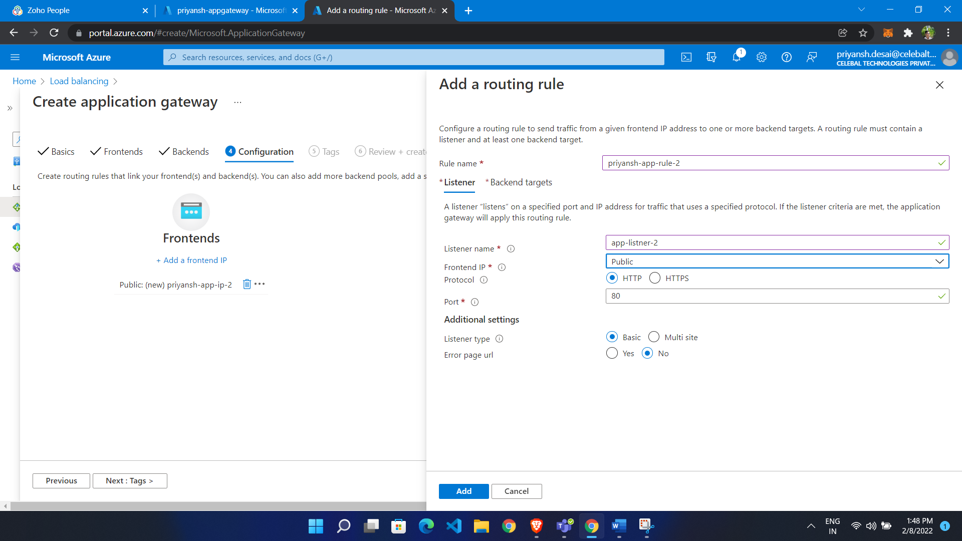

**Add backend**

Add backend pool

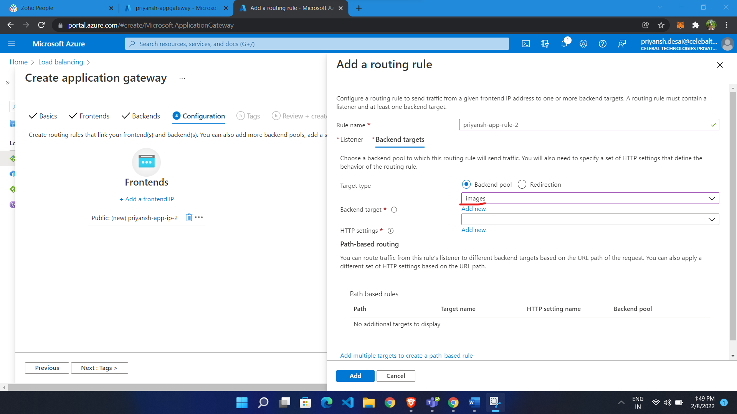

Now Configure HTTP setting

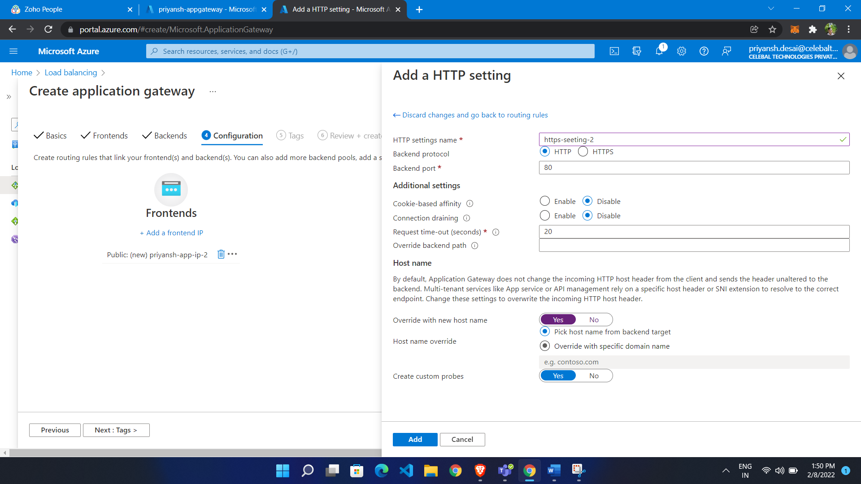

Now click add path

* Give path name /name/*
* Give target name
* http setting
* chose backend target

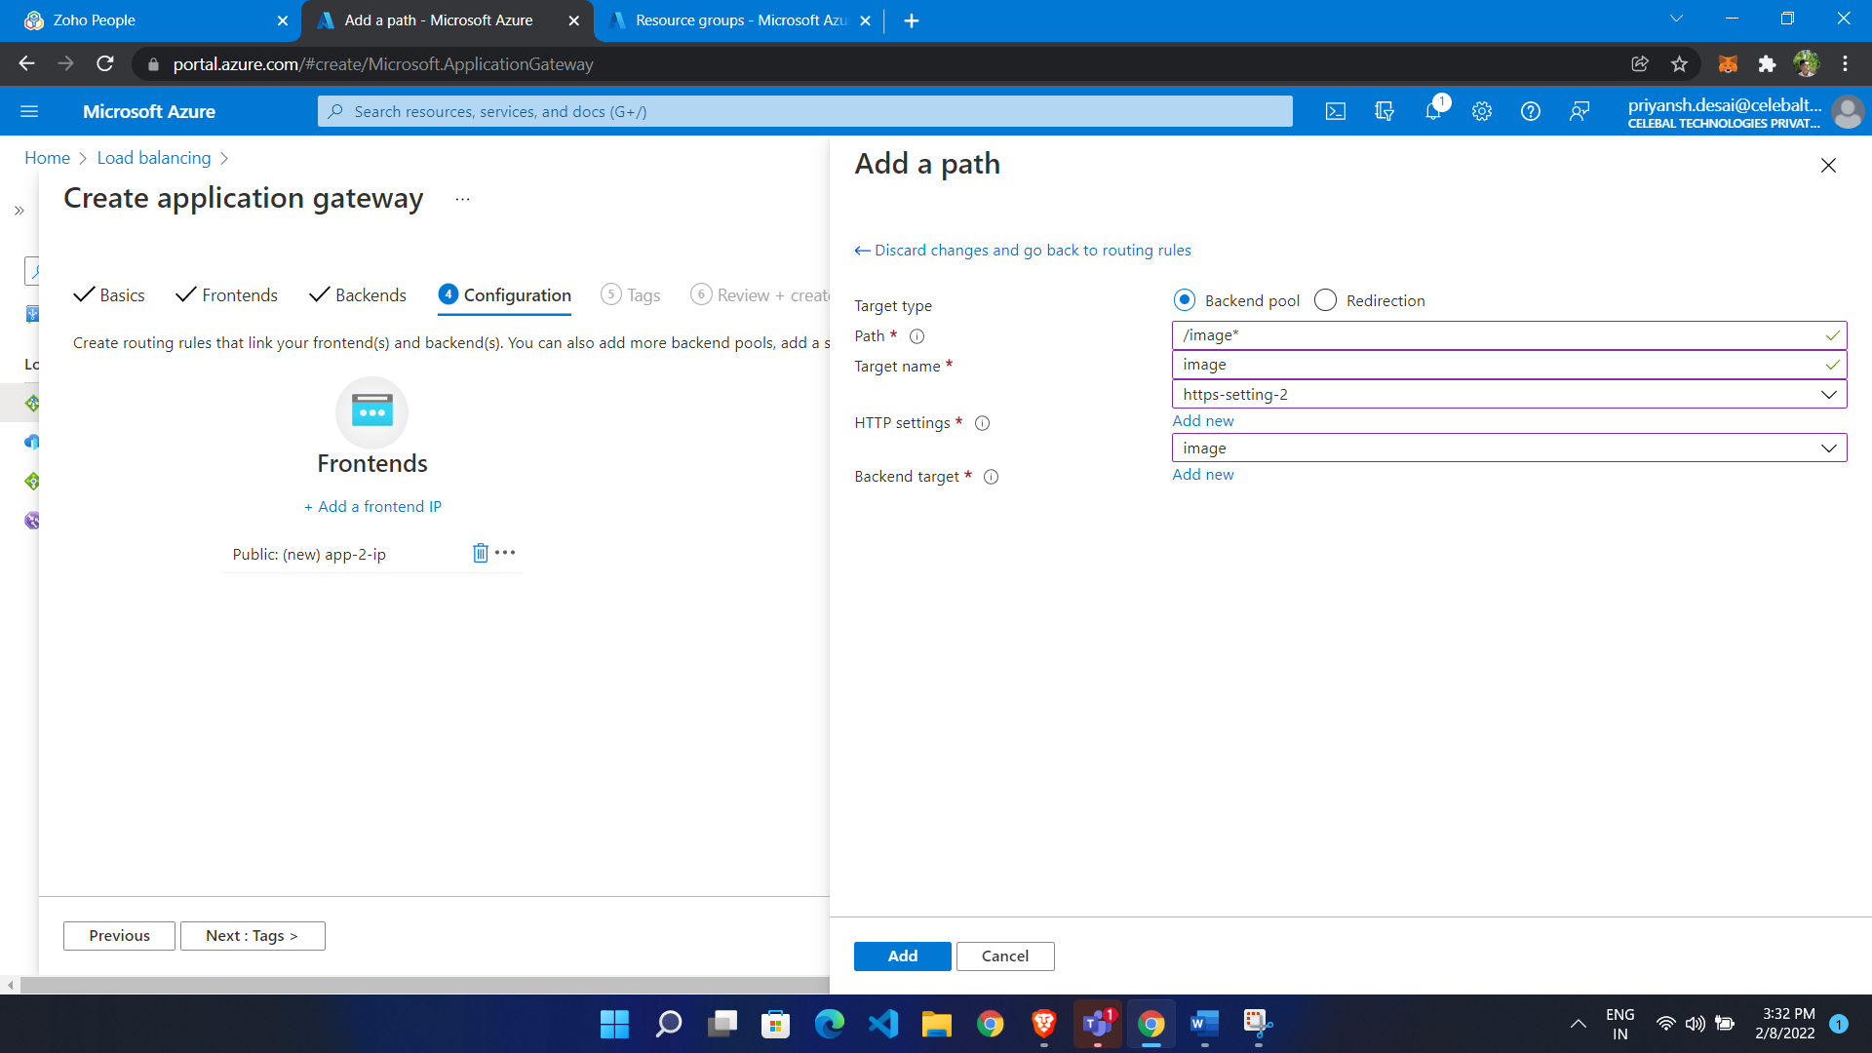

Add for video also

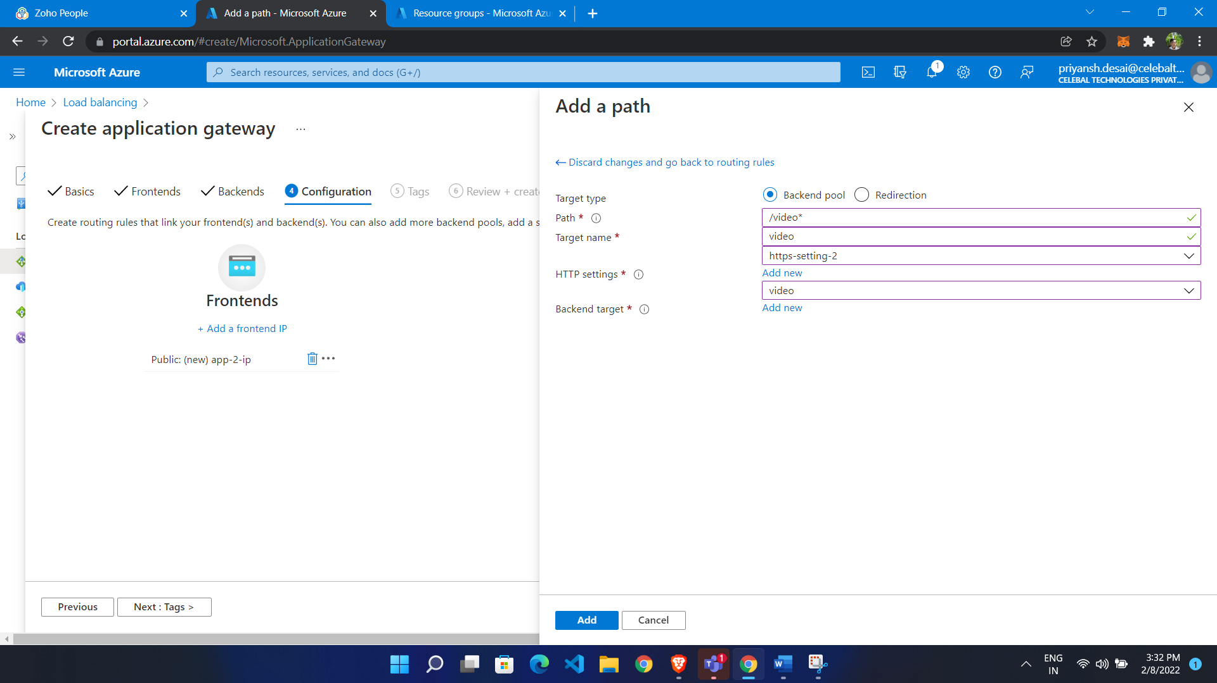

* Now go to Web app
* Click configuration
* Click add virtual path

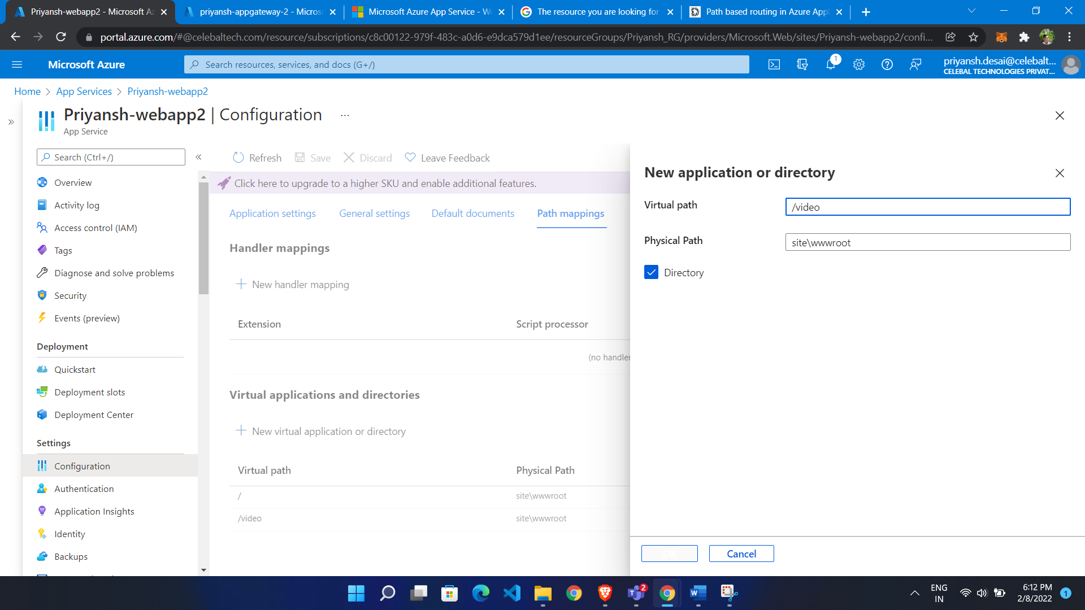

Same for image

We get response from /video

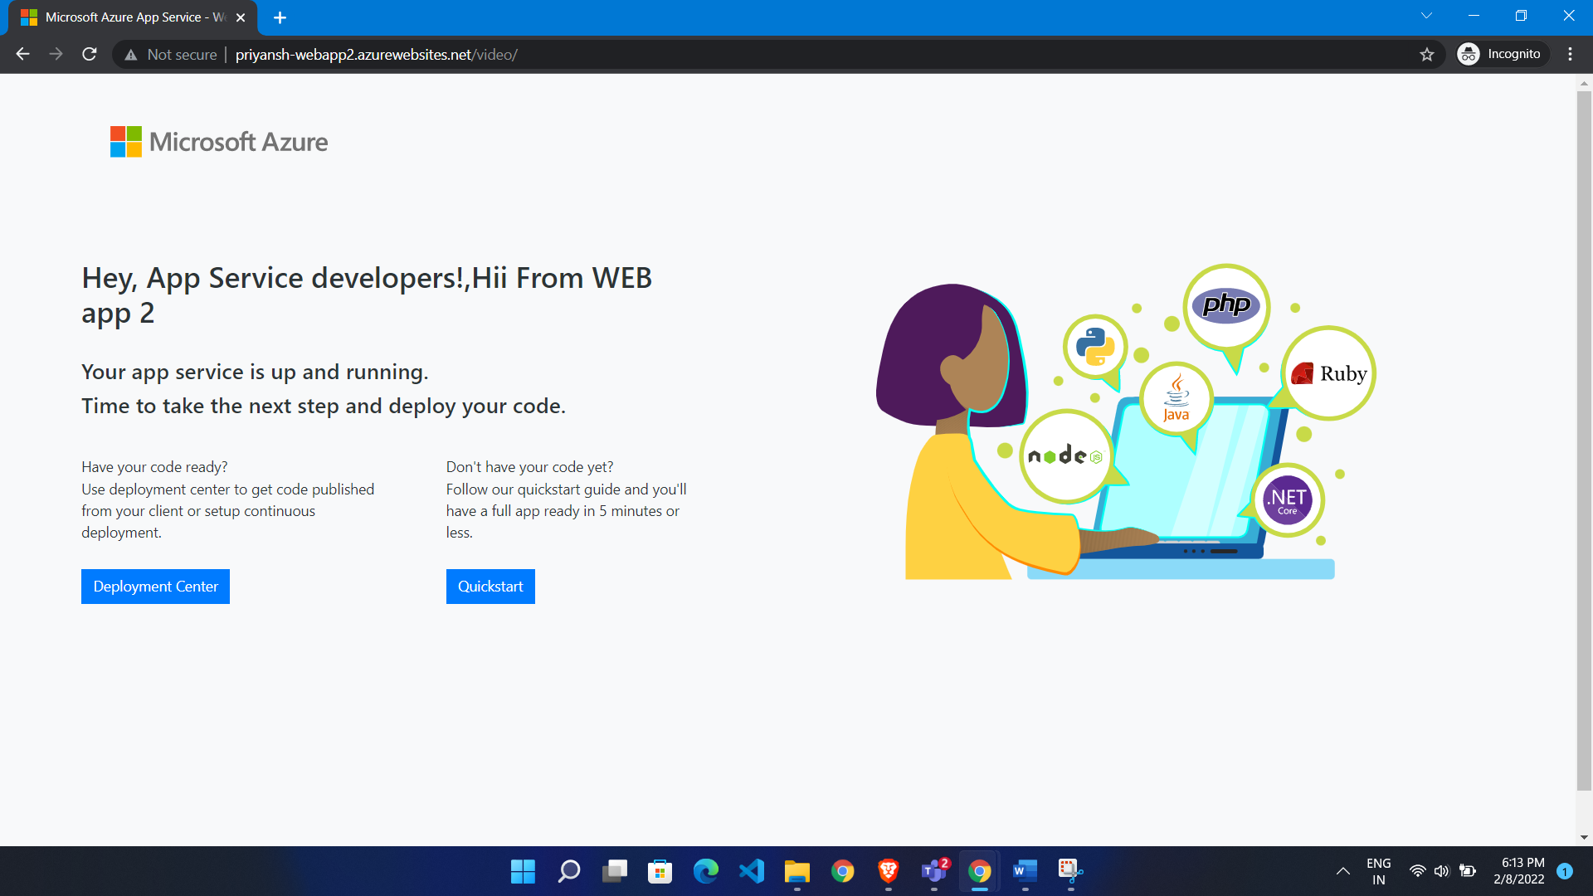

/Image

